Industrial Attachment Demo Project Report
Machine Learning–Based Process Optimization & Quality Improvement
Demonstration Project for BAT Industrial Attachment
Prepared by:
Apurbo Das
B.Sc. in Industrial & Production Engineering (IPE)
DUET, Gazipur

1. Introduction
This report presents a demonstration industrial project focused on process optimization and quality improvement in a factory environment using data analytics and machine learning. The objective of this demo project is to showcase an end-to-end data-driven approach that can be directly applied in British American Tobacco (BAT) factory operations during an industrial attachment.

2. Data Overview and Baseline KPIs
The demo dataset consists of 240 process observations collected from a simulated packing-line environment. The baseline performance indicators are summarized below:
- Average defect rate: 2.45%
- Median defect rate: 2.49%
- Minimum defect rate: 0.60%
- Maximum defect rate: 4.32%
- Acceptable limit: 3.0%
- Percentage of observations above limit: 21.2%

3. Correlation Analysis of Process Parameters
Correlation analysis was performed to identify relationships between key process parameters and defect rate. The heatmap below visually represents the strength and direction of these relationships.
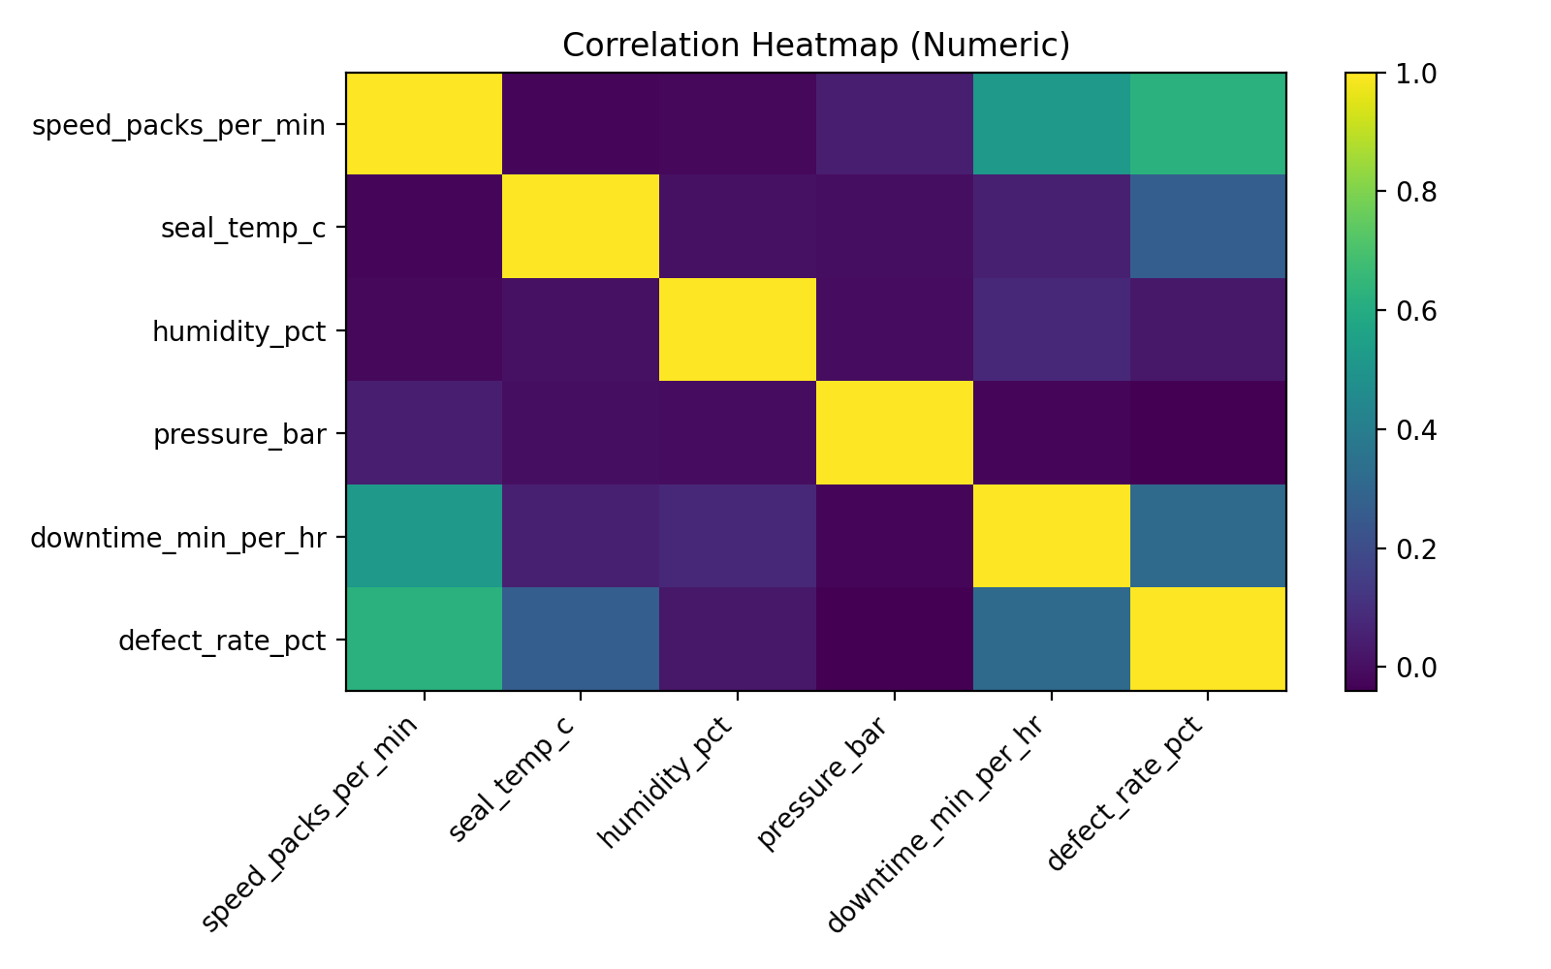
Key insight: Line speed and downtime show the strongest positive correlation with defect rate, indicating that these parameters are critical drivers of quality variation.

4. Machine Learning Model Development
Two regression models were developed and evaluated: Linear Regression and Random Forest Regression. Model performance was assessed using R², RMSE, and MAE metrics.
LinearRegression:
- R² score: 0.308
- RMSE: 0.449
- MAE: 0.361
RandomForest:
- R² score: 0.157
- RMSE: 0.496
- MAE: 0.380
Based on model stability and performance, Linear Regression was selected as the best-performing model for this demonstration dataset.

5. Optimized Operating Window
Using the selected machine learning model, thousands of parameter combinations were simulated. The best-performing 5% combinations (lowest predicted defect rates) were used to derive the recommended operating window below:
- speed_packs_per_min: 107.26 to 110.92
- seal_temp_c: 65.80 to 67.92
- humidity_pct: 47.39 to 61.33
- pressure_bar: 4.02 to 4.47
- downtime_min_per_hr: 1.88 to 5.47

6. Potential Benefits to BAT
- Reduction in defect and rejection rates without capital investment
- Improved process stability and consistency
- Data-driven decision support for process engineers
- Scalable framework applicable to multiple production lines
- Alignment with BAT’s Industry 4.0 and continuous improvement initiatives

7. Conclusion
This demo project demonstrates a complete, real-world applicable framework for manufacturing process optimization using machine learning. While this analysis is based on simulated factory-like data, the same methodology and code pipeline can be directly applied to BAT’s real production data during an industrial attachment to generate actionable, factory-ready insights.

